LAB ACTIVITY 15
NAME : Dhevishree GN
REG NO : 22MID0136;
COURSE CODE: CSI3007; LAB : L7+L8; DATE : 23/09/2025
DIGITAL ASSIGNMENT-4
TASK - 1: The Life Cycle of Matplotlib
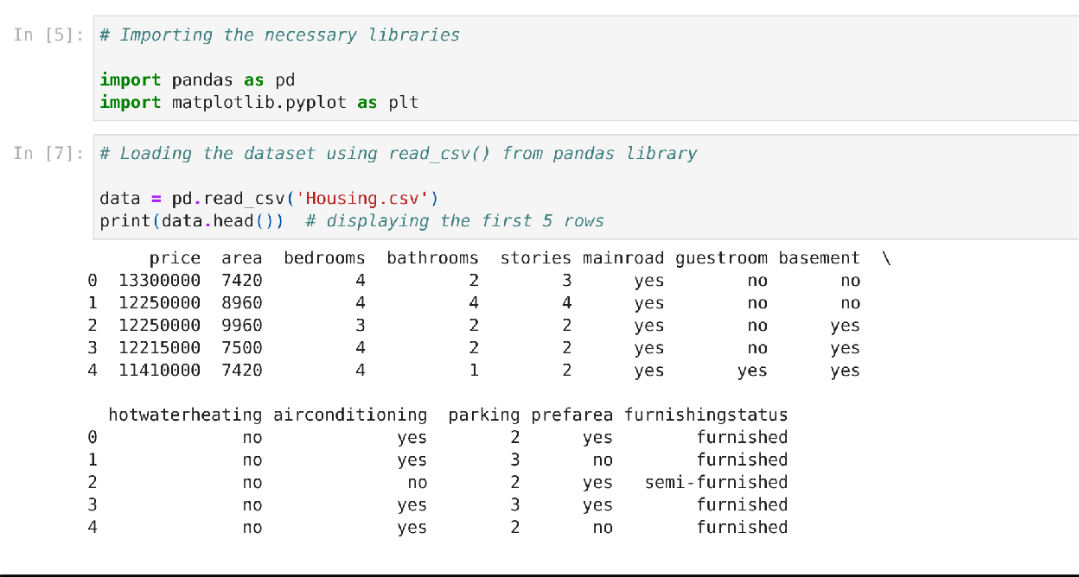

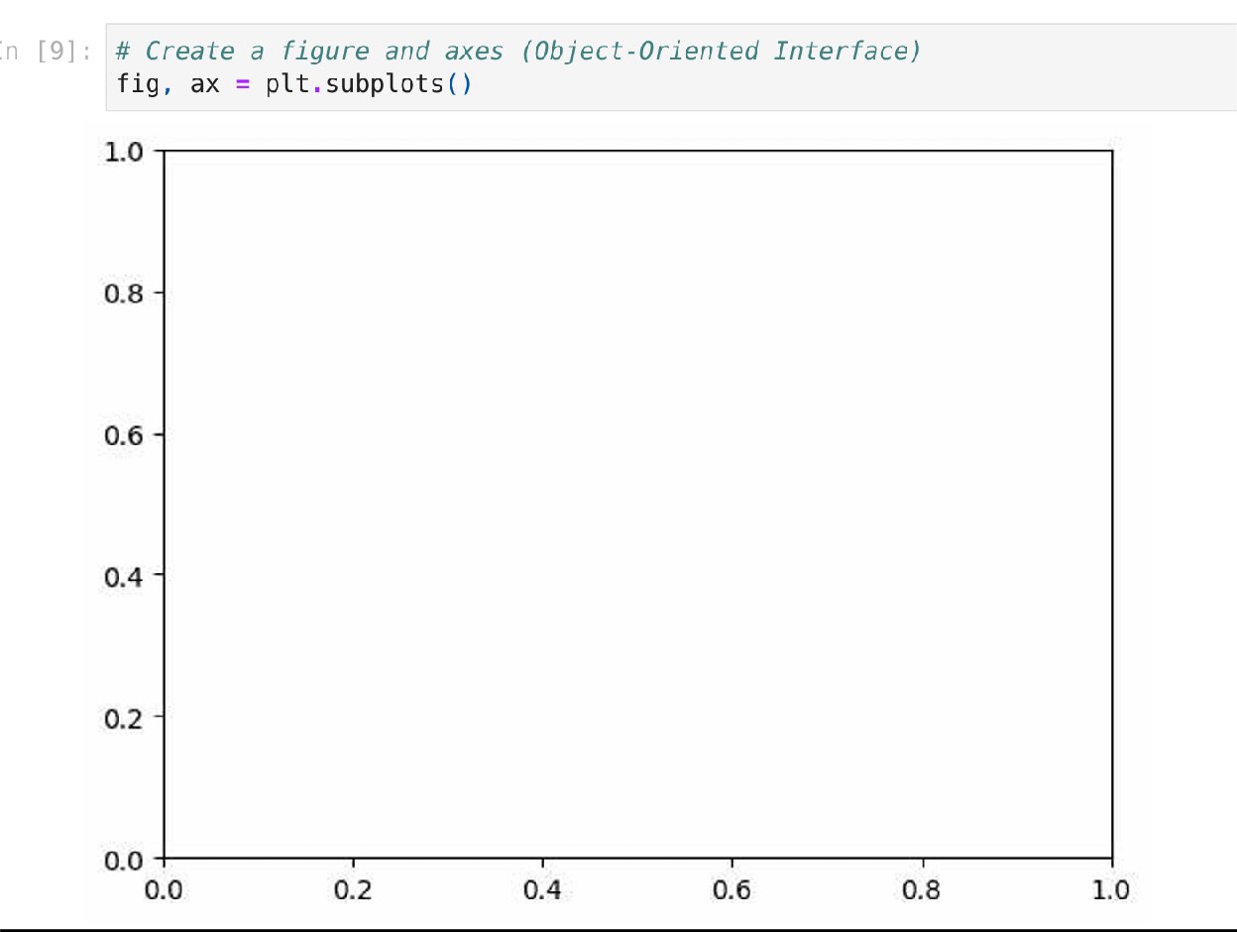
: fig, ax = plt.subplots() # Plot data on axes
ax.plot(data["area"], data["price"], color="blue", marker="o", linestyle="-", label="Price vs Area")
# Customize plot (labels, title, legend, grid) ax.set_xlabel("Area (sq ft)")
ax.set_ylabel("Price (INR)")
ax.set_title("Housing Price vs Area") ax.legend() ax.grid(True)

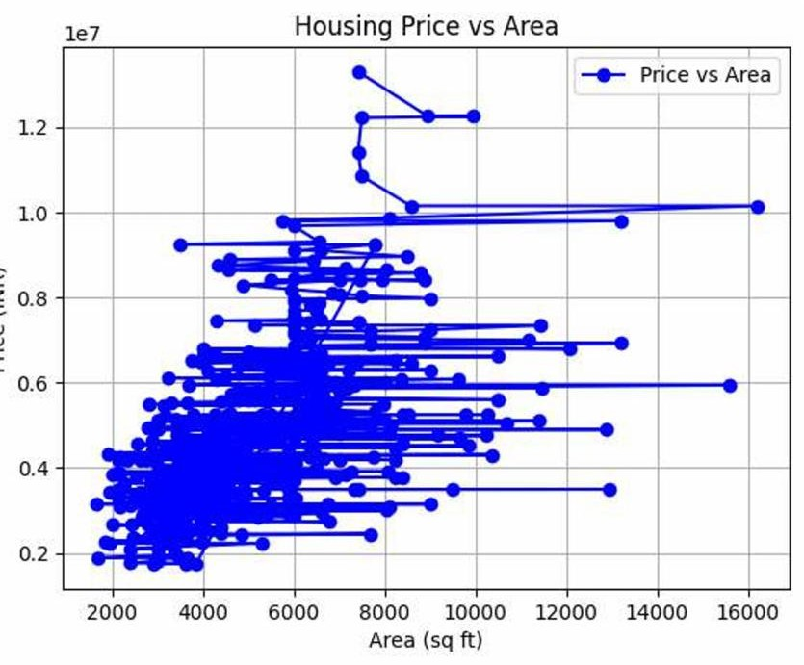
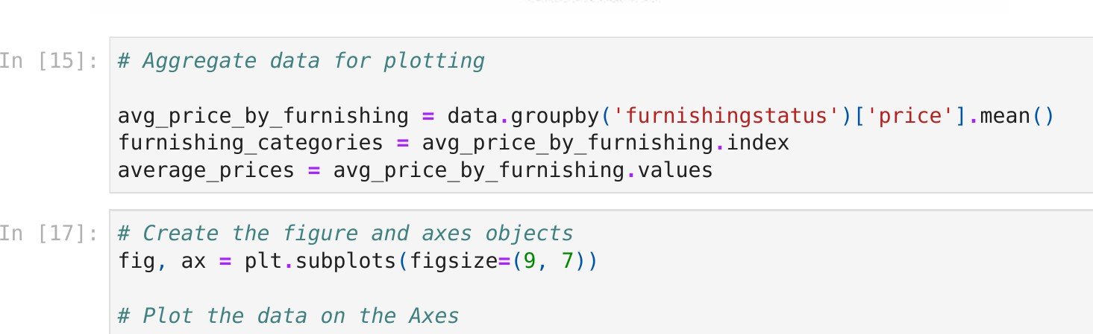
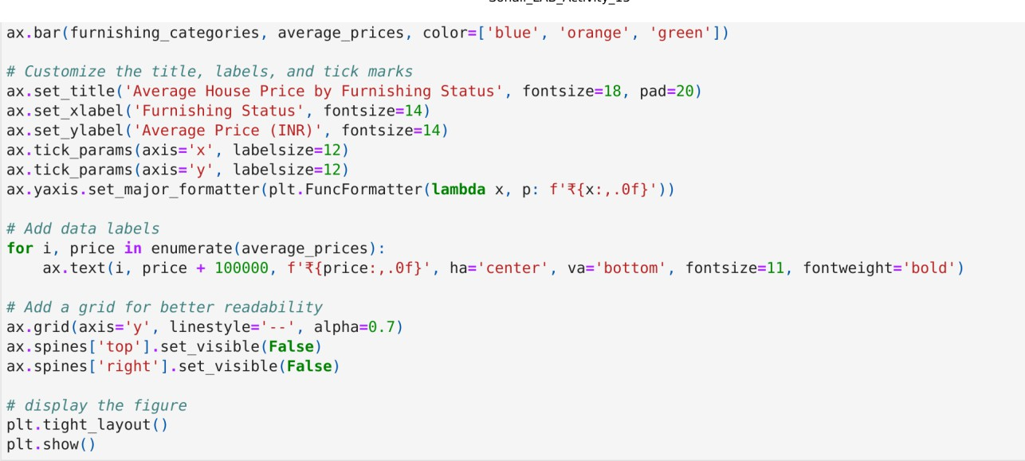

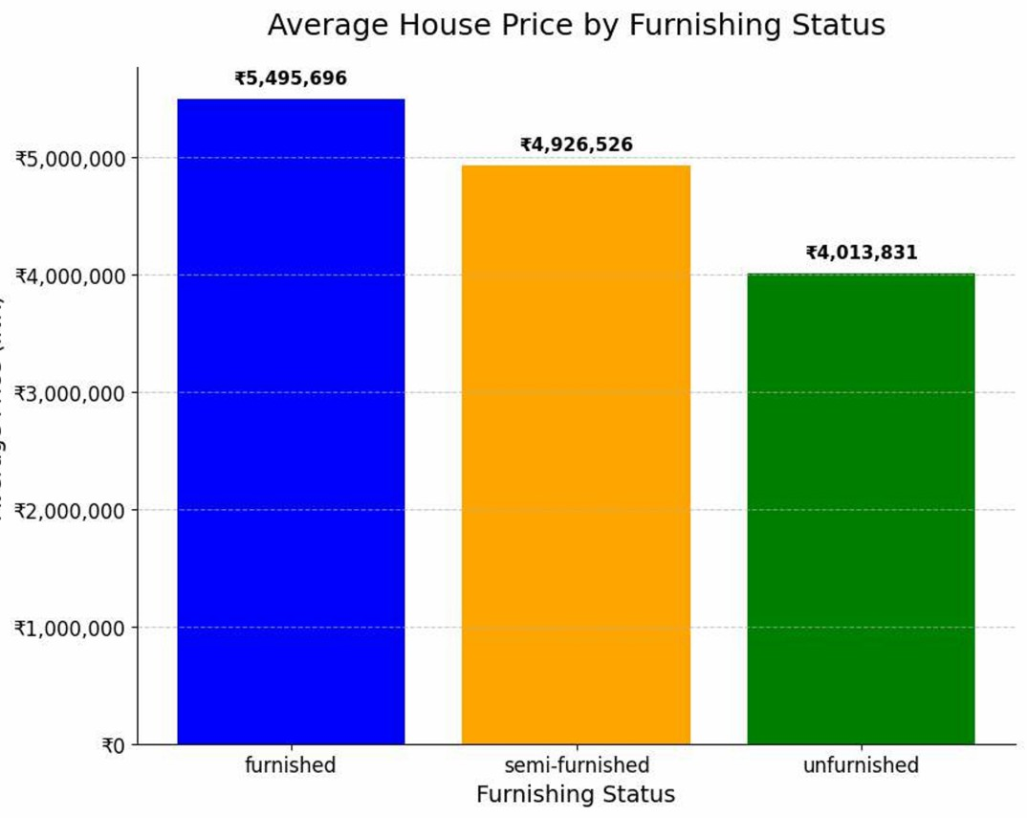
TASK - 2: Load the Image and change its characterstics (Brightness, hue, saturation)
import cv2
import matplotlib.pyplot as plt

# Load image (change path as needed)
image = cv2.imread("sample.jpg") # reads in BGR format
image = cv2.cvtColor(image, cv2.COLOR_BGR2RGB) # convert to RGB for matplotlib

# --- Brightness Adjustment ---
def adjust_brightness(img, factor=1.2):
hsv = cv2.cvtColor(img, cv2.COLOR_RGB2HSV).astype("float32") h, s, v = cv2.split(hsv)

v = v * factor
v = np.clip(v, 0, 255)
hsv = cv2.merge([h, s, v])
return cv2.cvtColor(hsv.astype("uint8"), cv2.COLOR_HSV2RGB)

# --- Saturation Adjustment ---
def adjust_saturation(img, factor=1.5):
hsv = cv2.cvtColor(img, cv2.COLOR_RGB2HSV).astype("float32") h, s, v = cv2.split(hsv)
s = s * factor
s = np.clip(s, 0, 255)
hsv = cv2.merge([h, s, v])
return cv2.cvtColor(hsv.astype("uint8"), cv2.COLOR_HSV2RGB)

# --- Hue Adjustment ---
def adjust_hue(img, shift=30): # shift hue by 30 degrees hsv = cv2.cvtColor(img, cv2.COLOR_RGB2HSV)
h, s, v = cv2.split(hsv)
h = (h.astype(int) + shift) % 180 # Hue range is [0,179] hsv = cv2.merge([h.astype("uint8"), s, v])
return cv2.cvtColor(hsv, cv2.COLOR_HSV2RGB)

# Apply transformations
bright_img = adjust_brightness(image, 1.5) saturated_img = adjust_saturation(image, 1.8) hue_img = adjust_hue(image, 40)

# Show Results
titles = ["Original", "Brightness", "Saturation", "Hue"]
images = [image, bright_img, saturated_img, hue_img]

plt.figure(figsize=(12,6)) for i in range(4):
plt.subplot(1,4,i+1)
plt.imshow(images[i]) plt.title(titles[i])
plt.axis("off") plt.show()
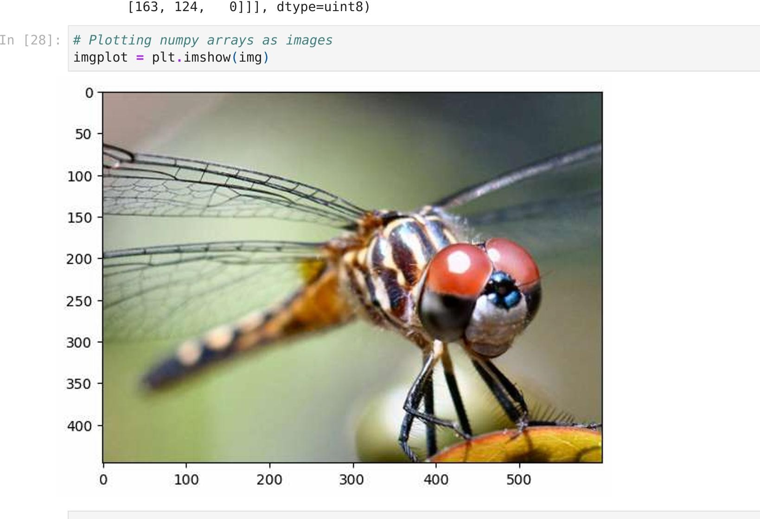
APPLYING PSEUDO CODE:

import cv2
import matplotlib.pyplot as plt

# Load image in grayscale
gray_img = cv2.imread("sample.jpg", cv2.IMREAD_GRAYSCALE)

# Apply pseudocolor maps
color1 = cv2.applyColorMap(gray_img, cv2.COLORMAP_JET) # Jet colormap (rainbow style) color2 = cv2.applyColorMap(gray_img, cv2.COLORMAP_HOT) # Hot colormap
color3 = cv2.applyColorMap(gray_img, cv2.COLORMAP_OCEAN) # Ocean colormap

# Convert BGR (OpenCV default) to RGB for matplotlib color1 = cv2.cvtColor(color1, cv2.COLOR_BGR2RGB) color2 = cv2.cvtColor(color2, cv2.COLOR_BGR2RGB) color3 = cv2.cvtColor(color3, cv2.COLOR_BGR2RGB)

# Display results
titles = ["Grayscale", "Pseudocolor: JET", "Pseudocolor: HOT", "Pseudocolor: OCEAN"] images = [gray_img, color1, color2, color3]

plt.figure(figsize=(12,6)) for i in range(4):
plt.subplot(1,4,i+1) if i==0:
plt.imshow(images[i], cmap="gray") else:

plt.imshow(images[i]) plt.title(titles[i])
plt.axis("off") plt.show()
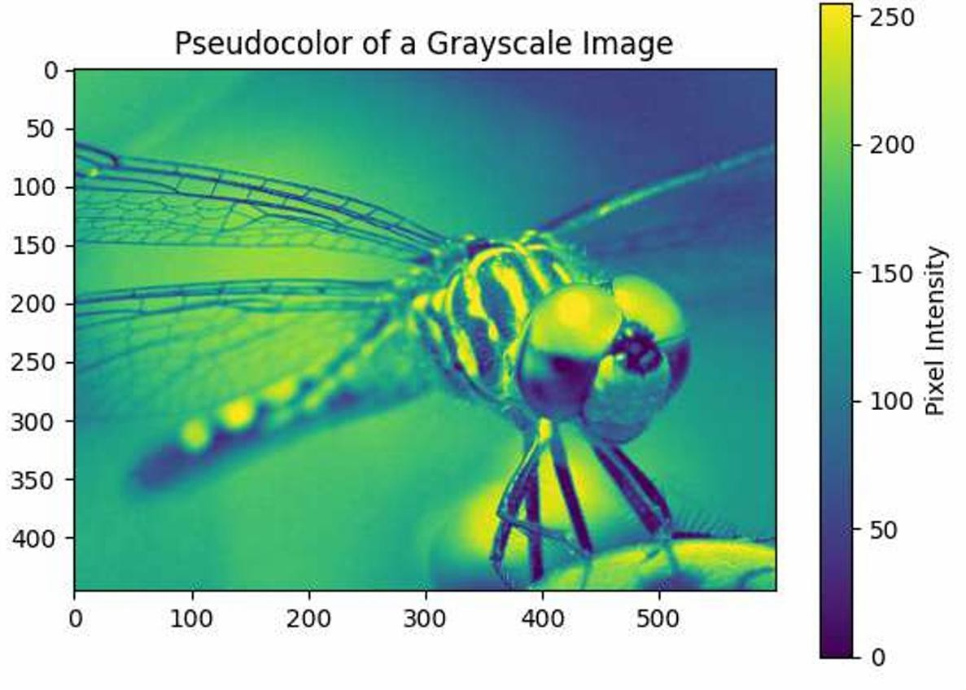
Explanation:
The original image (img) is a 3D NumPy matrix → [height, width, 3/4] (RGB).

# luminosity (2D, no color) image, the default is called viridis. There are plenty of others (ex: hot)
plt.imshow(lum_img, cmap="hot") Out[66]

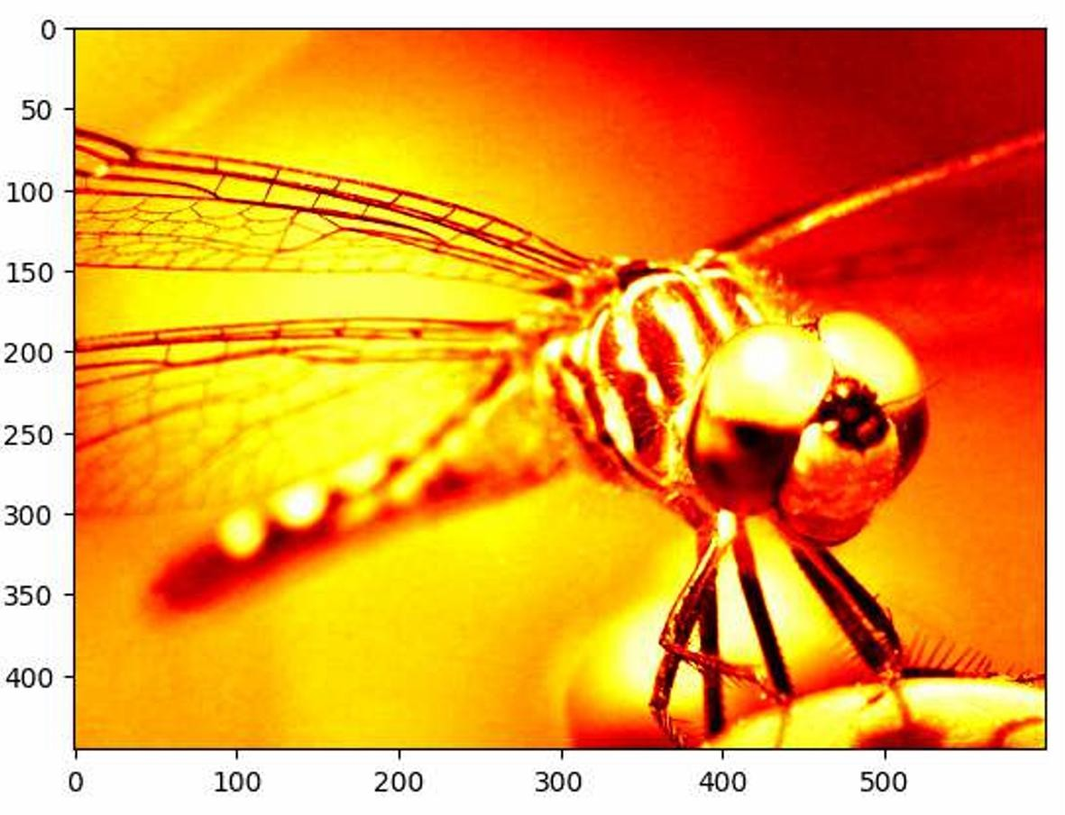
:
import cv2
import matplotlib.pyplot as plt

# Load grayscale image
gray_img = cv2.imread("sample.jpg", cv2.IMREAD_GRAYSCALE)

# List of all colormaps colormaps = [
cv2.COLORMAP_AUTUMN, cv2.COLORMAP_BONE, cv2.COLORMAP_JET, cv2.COLORMAP_WINTER, cv2.COLORMAP_RAINBOW, cv2.COLORMAP_OCEAN, cv2.COLORMAP_SUMMER, cv2.COLORMAP_SPRING, cv2.COLORMAP_COOL, cv2.COLORMAP_HSV, cv2.COLORMAP_PINK, cv2.COLORMAP_HOT,
cv2.COLORMAP_PARULA, cv2.COLORMAP_MAGMA, cv2.COLORMAP_INFERNO, cv2.COLORMAP_PLASMA, cv2.COLORMAP_VIRIDIS, cv2.COLORMAP_CIVIDIS,

cv2.COLORMAP_TWILIGHT, cv2.COLORMAP_TWILIGHT_SHIFTED, cv2.COLORMAP_TURBO, cv2.COLORMAP_DEEPGREEN
]

names = [
"AUTUMN","BONE","JET","WINTER","RAINBOW","OCEAN","SUMMER",
"SPRING","COOL","HSV","PINK","HOT","PARULA","MAGMA", "INFERNO","PLASMA","VIRIDIS","CIVIDIS","TWILIGHT",
"TWILIGHT_SHIFTED","TURBO","DEEPGREEN"
]

plt.figure(figsize=(15,12))
for i, (cmap, name) in enumerate(zip(colormaps, names)): color_img = cv2.applyColorMap(gray_img, cmap)
color_img = cv2.cvtColor(color_img, cv2.COLOR_BGR2RGB)

plt.subplot(5,5,i+1)
plt.imshow(color_img) plt.title(name)
plt.axis("off")

plt.tight_layout() plt.show()

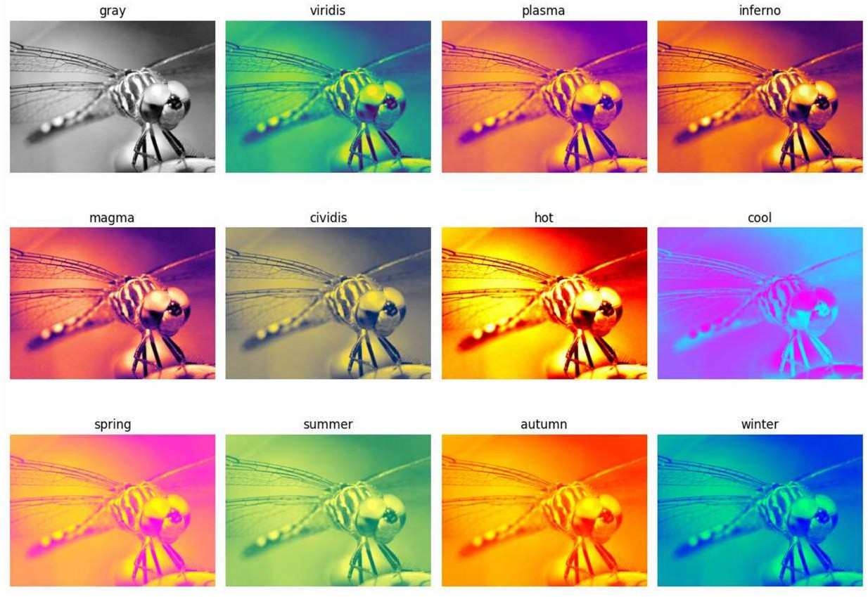
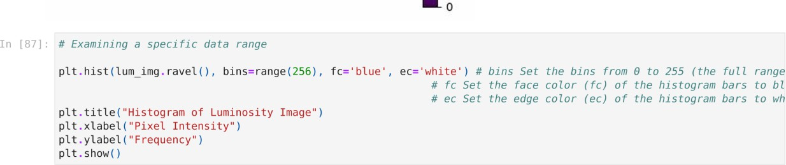

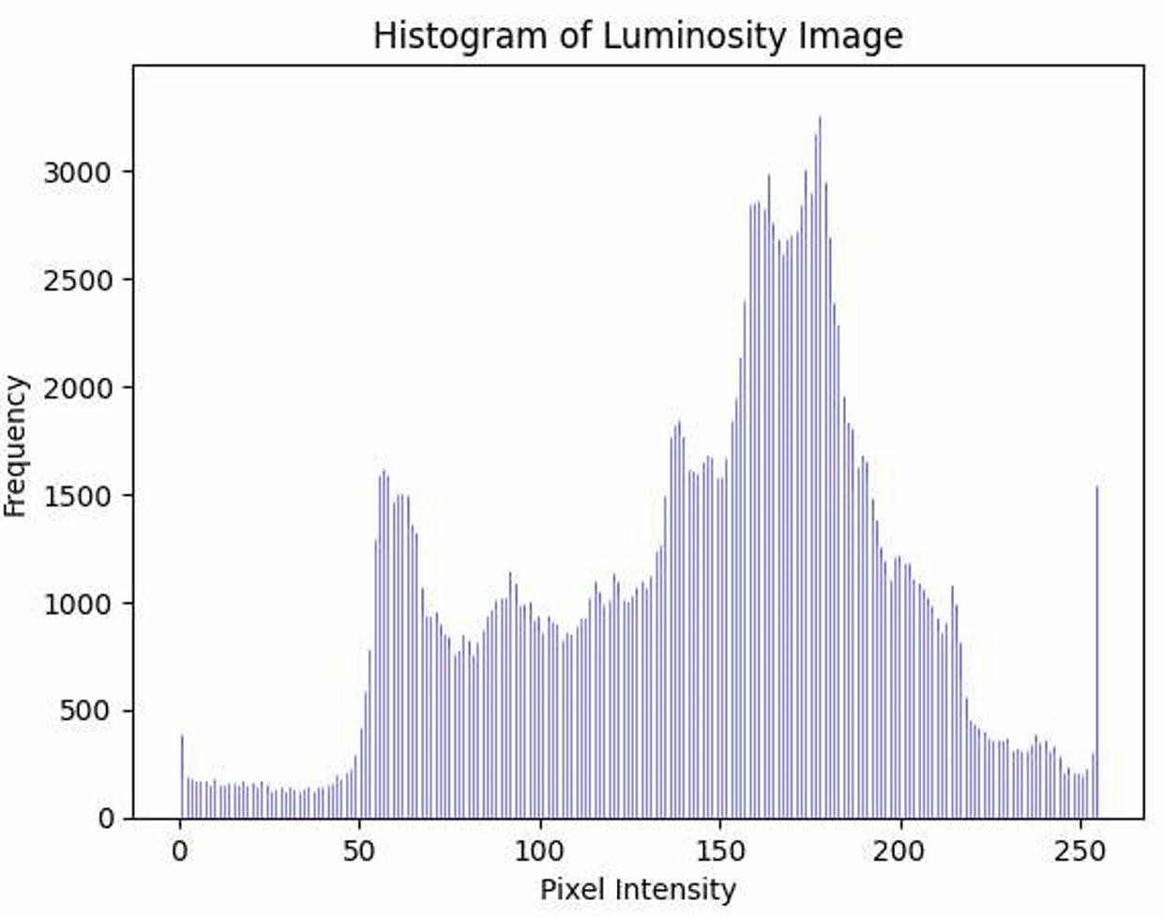
TASK - 3: Finding the inverse of image (In Matrix of pixel values) and finding the negative image (inverted image)
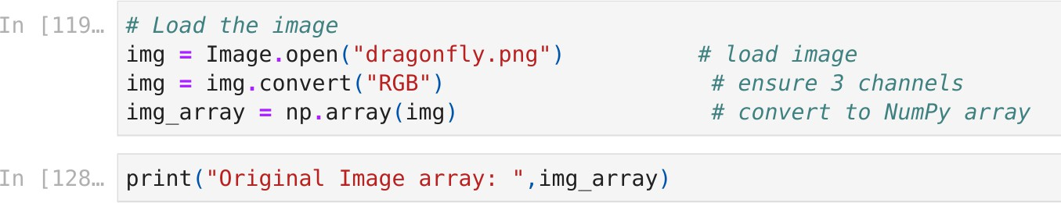

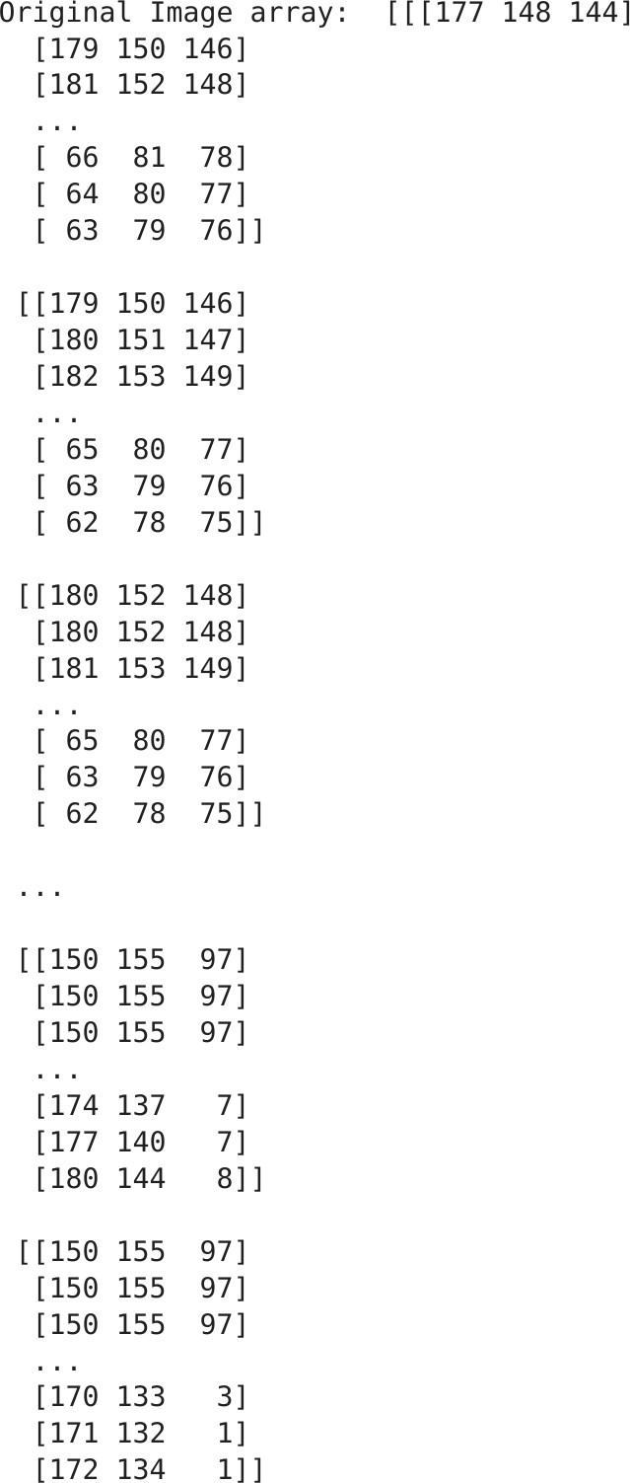

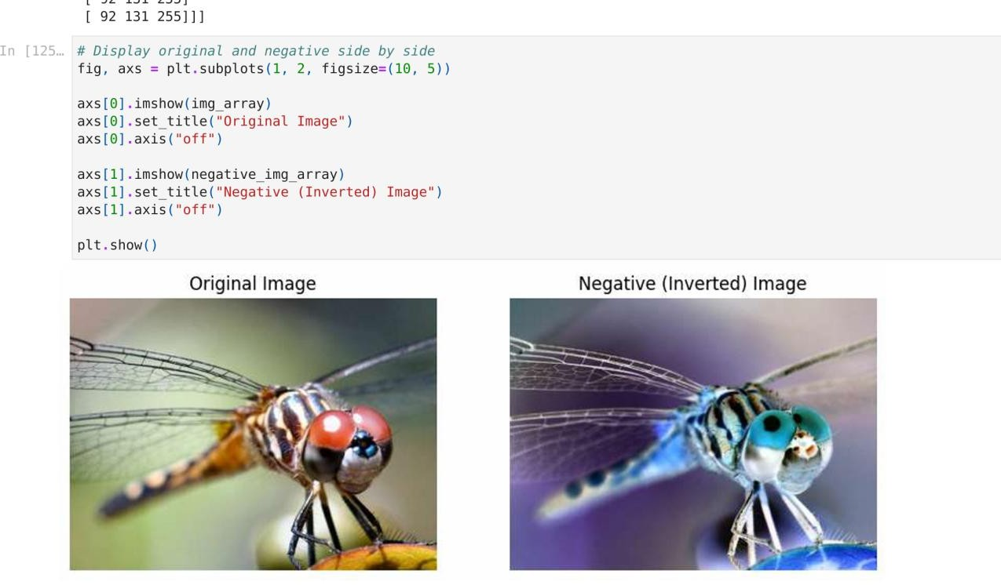
TASK - 4: Plotting numerical data, categorical data, text data (Word cloud), ordinal data, audio data and image data
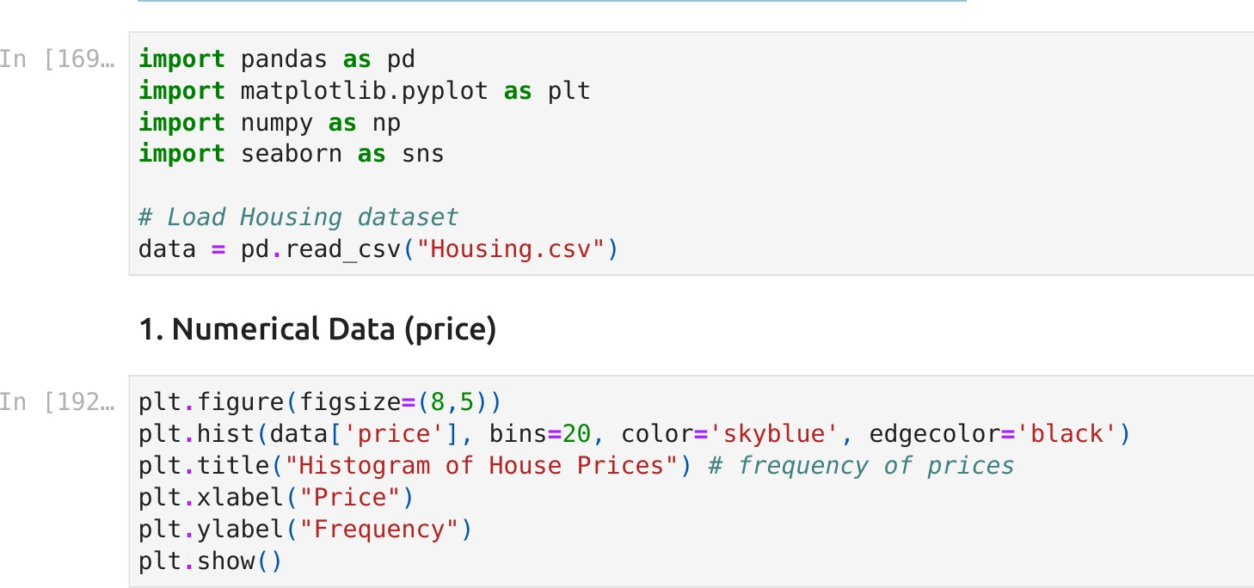

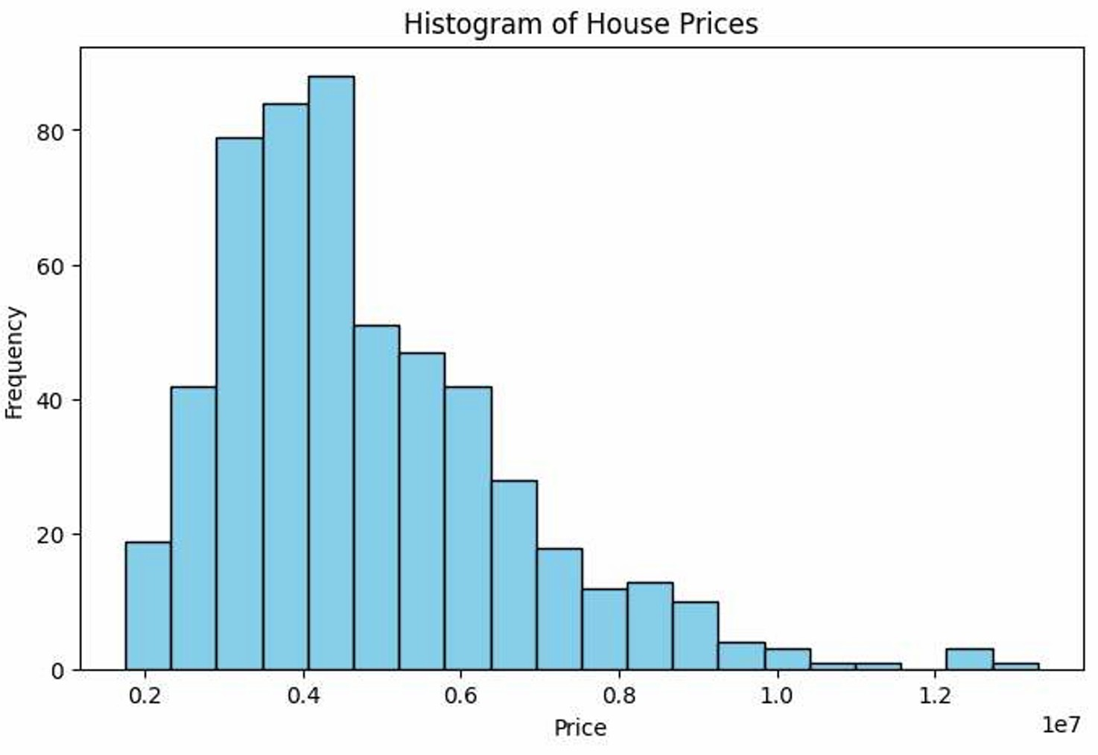

LAB ACTIVITY 16
NAME : Dhevishree GN;
REG NO : 22MID0136; COURSE CODE: CSI3007; LAB : L7+L8; DATE : 30/09/2025
MultiIndex creation, indexing, slicing, swapping, alignment, and advanced operations in Pandas.

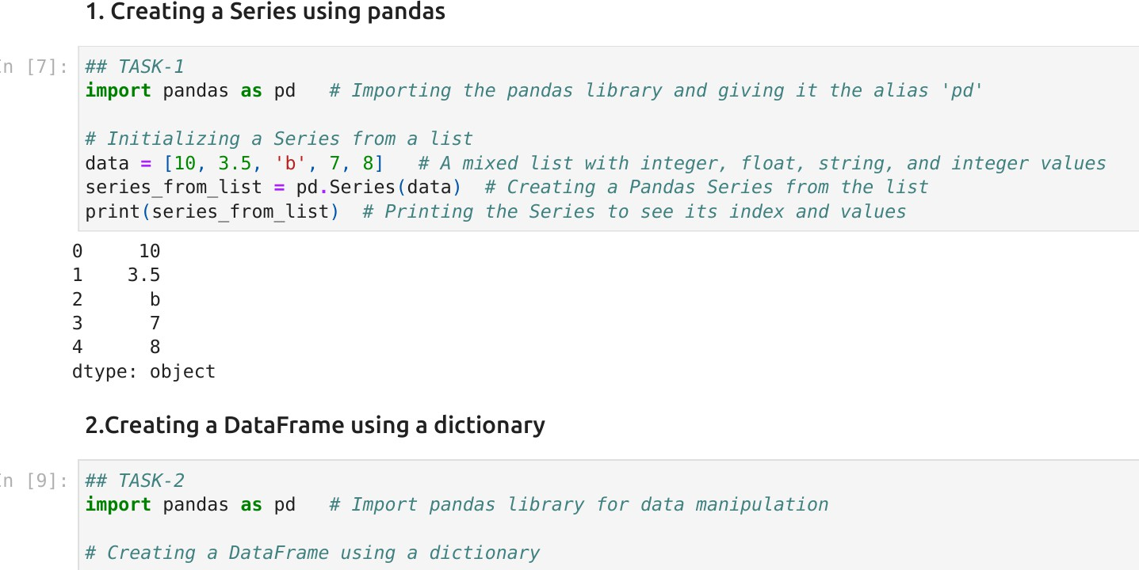
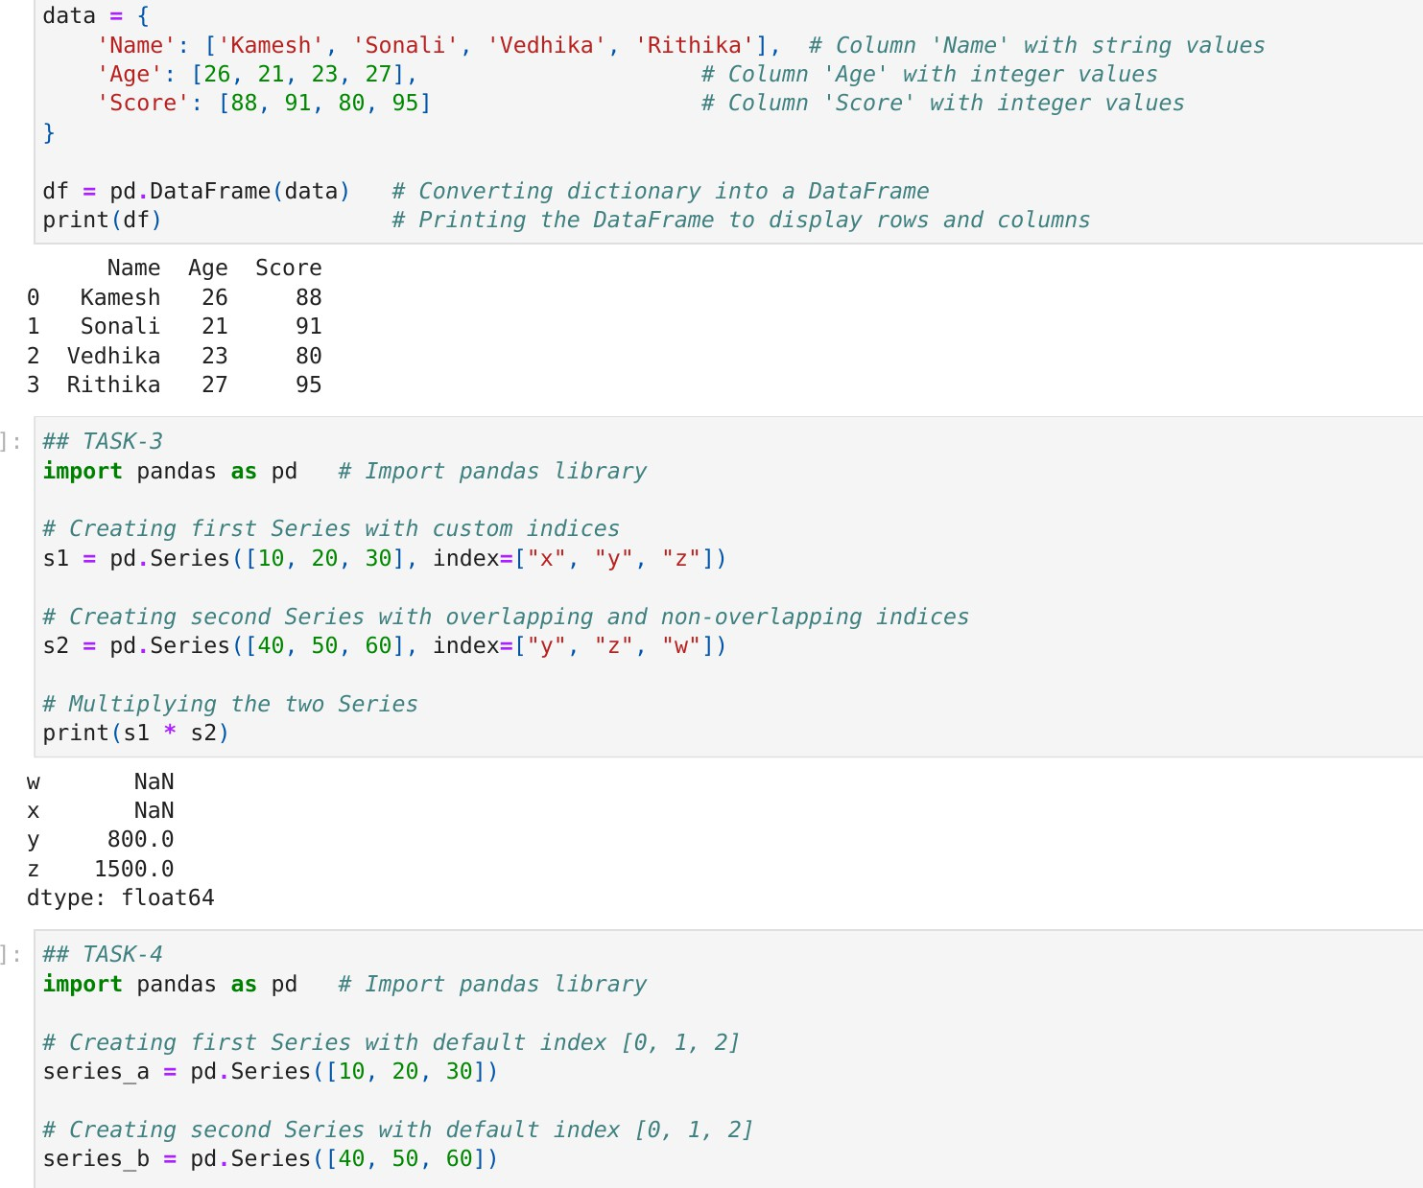

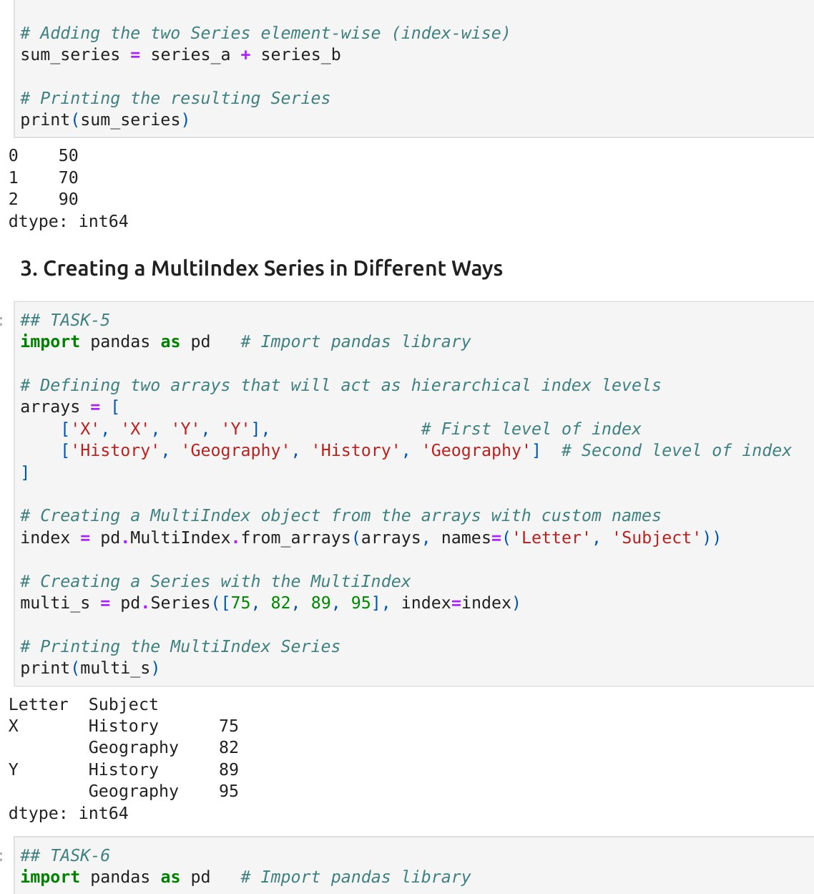

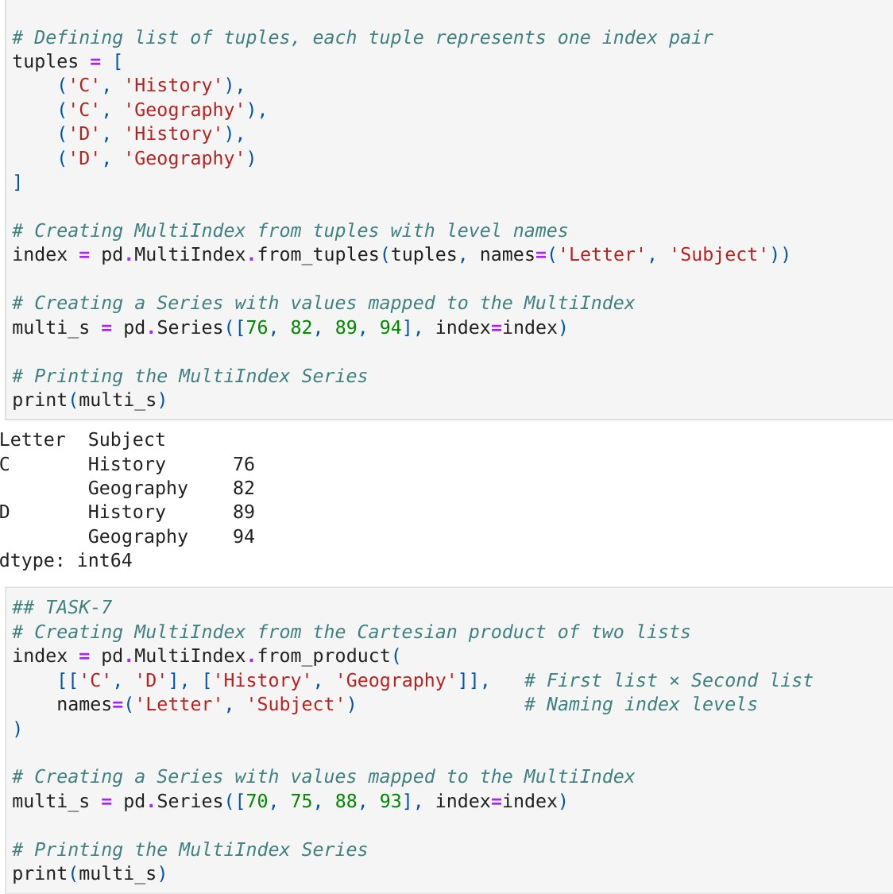

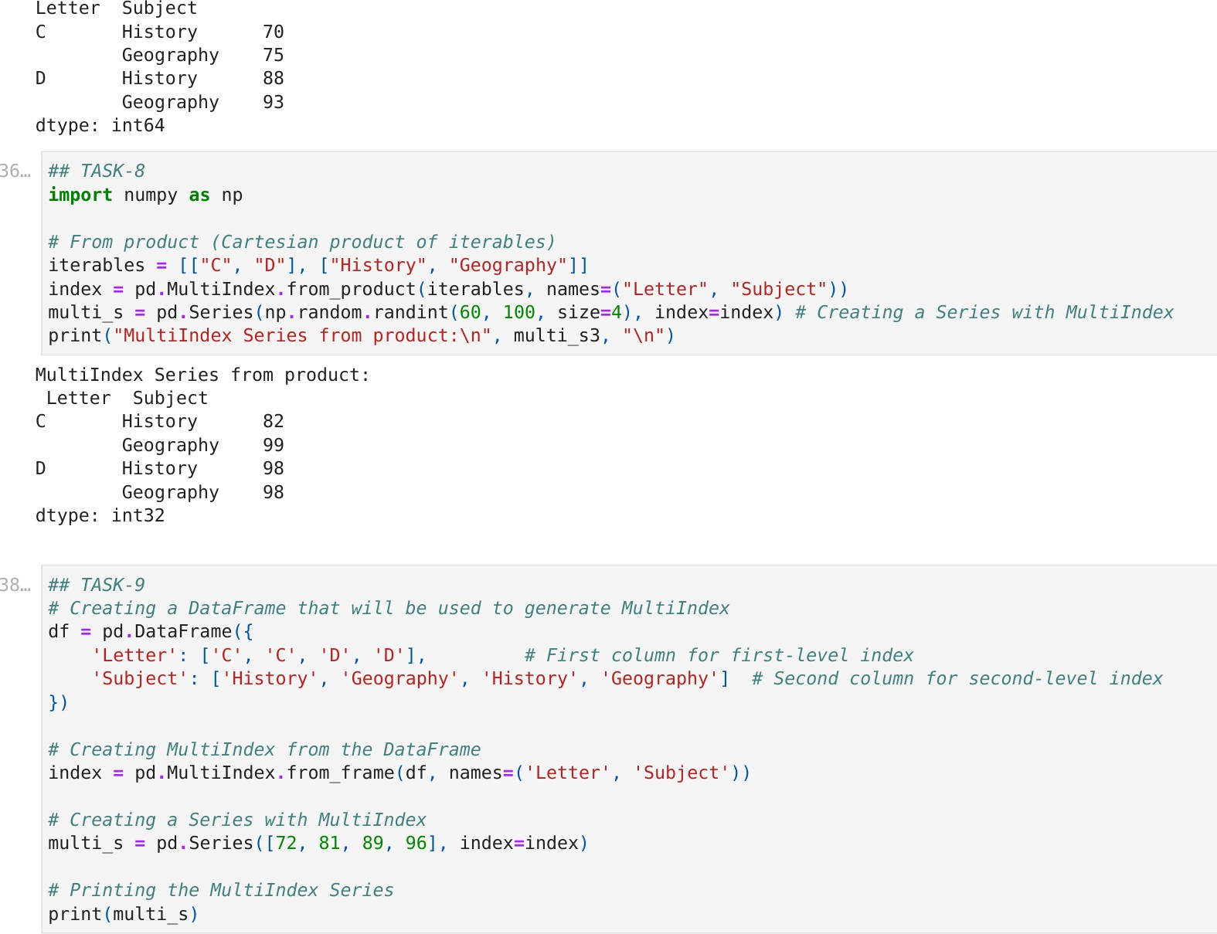

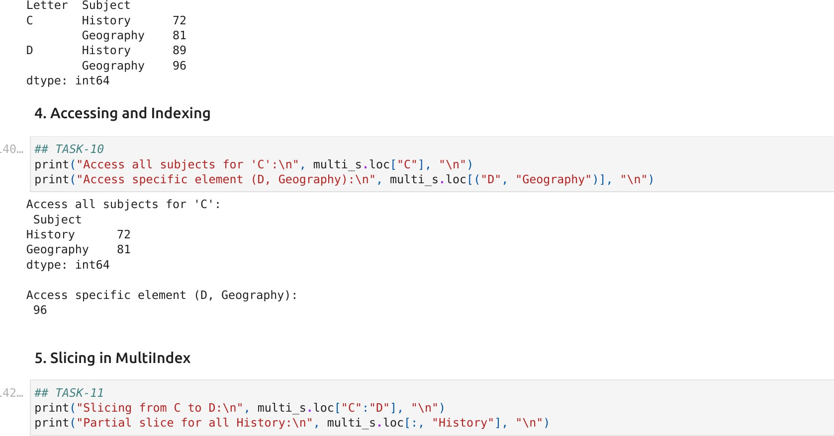

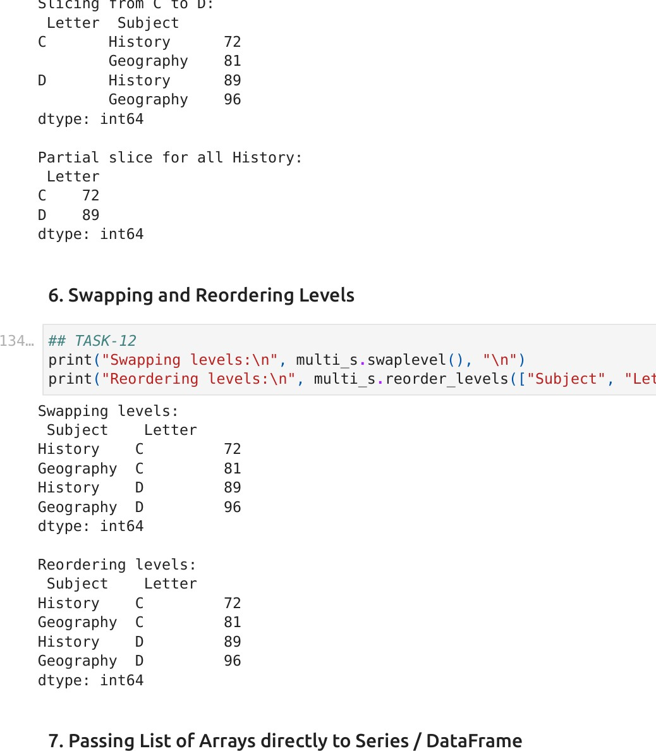

LAB ACTIVITY 17
NAME :Dhevishree GN;

REG NO : 22MID0136; COURSE CODE: CSI3007; LAB : L7+L8; DATE : 03/10/2025
Essential Data Analysis Techniques in Python: DataFrames, indexing, grouping, merging, and pivot tables in Pandas.
1.Creating DataFrames (different ways)
import pandas as pd

# Create a DataFrame from dictionary data = {
"Name": ["Alice", "Bob", "Charlie", "David"], "Age": [24, 27, 22, 32],
"Department": ["HR", "IT", "Finance", "IT"], "Salary": [45000, 54000, 50000, 60000]
}
df = pd.DataFrame(data) print(df)
